**CODING ASSESMENT -1**

**PET ADOPTION PLATFORM**

1)Script that initializes the database for the Pet Adoption Platform "PetPals".

create database PetPals;



2) create table Pets(Pet_id int primary key,Name text,Age int,Breed text,Type text,Available_for_Adoption bit);



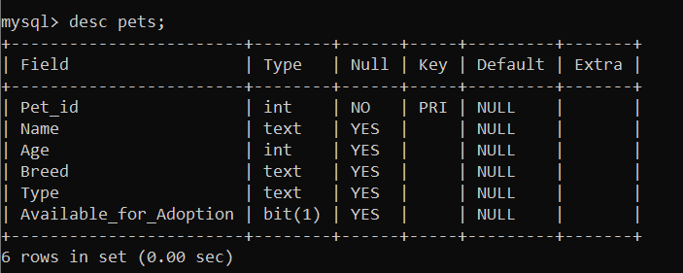

create table Shelters(Shelter_Id int primary key,Name text,Location text);

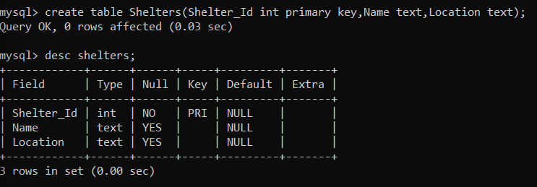

create table Donations(Donation_id int primary key,Donor_name text,Donation_type enum ("cash","item"),Donation_amount decimal(10,2),Donation_item text,Donation_date datetime);

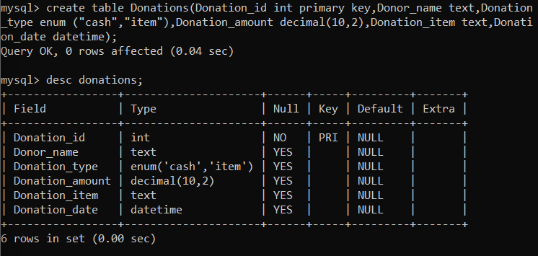

create table Adoption_Events(Event_id int primary key,Event_name varchar(50),Event_Date datetime,Location varchar(100));

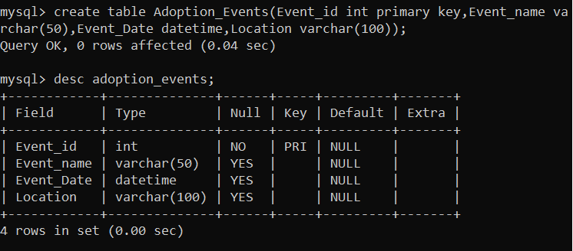

3) appropriate primary keys, foreign keys, and constraints.

create table Participants (Participant_id int primary key,Participant_Name text,Participant_Type enum("Shelter","Adopter"),Event_id int,foreign key(event_id) references adoption_events(event_id));

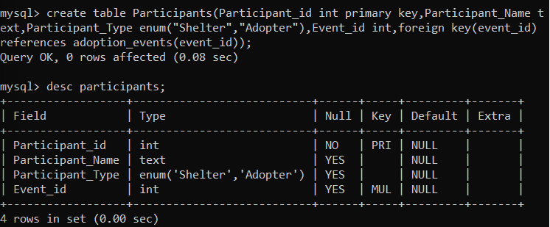

4. potential errors, such as if the database or tables already exist.



Inserting values

insert into pets values

(1,'Jack', 3 , 'Afollie', 'Dog',1),

(2, 'Jill', 2 , 'Maine Coon', 'Cat', 0),

(3, 'Kitto', 1 , 'Doberman', 'Dog', 0),

(4, 'Siva', 3 , 'Persian cat', 'Cat', 1),

(5, 'Tiger', 1 , 'Siberian Huskey', 'Dog', 1),

(6, 'Shilly', 3, 'Siberian cat', 'Cat',0),

(7, 'Tommy',1, 'Golden retriener', 'Dog', 1),

(8, 'Julie',2, 'Himalayan Cat', 'Cat', 0),

(9, 'Viba', 4, 'German sherpard', 'Dog', 1),

(10, 'Rosy',1, 'Bombay Cat','Cat', 0);

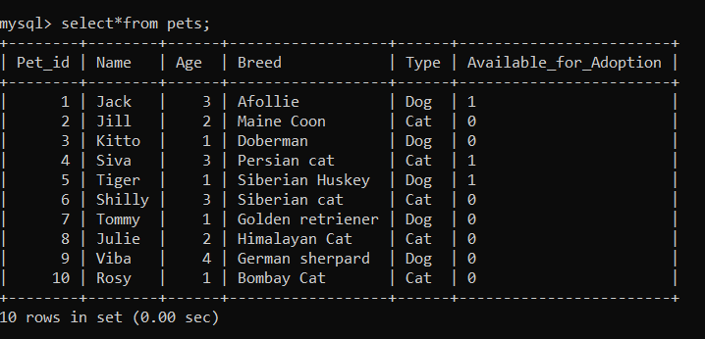

Shelter

insert into shelters values (1, 'The Doghouse', '999 Pine Lane'),

(2, 'Furry Friends Haven', '121 Cedar Avenue'),

(3, 'Paw Prints Paradise', '232 Oakwood Lane'),

(4, 'Meow Manor', '343 Birch Avenue'),

(5, 'Bulldog Bliss', '454 Elm Lane'),

(6, 'Poodle Palace', '565 Maple Street'),

(7, 'Siamese Serenity', '676 Sycamore Avenue'),

(8, 'Greyhound Getaway', '787 Pinecone Lane'),

(9, 'Husky Hideout', '898 Rosewood Street'),

(10, 'Calico Comfort', '909 Juniper Avenue');

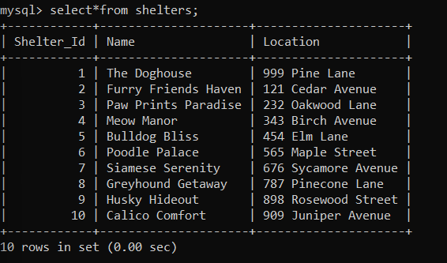

Donations

insert into Donations values

(1,'Martin','Cash',500.00,'null','2023-05-10 09:30:00'),

(2,'Charlie','Item',null,'pet toys','2023-05-12 14:45:00'),

(3,'David','item',null,'pet food','2023-05-15 18:20:00'),

(4,'Knia','cash',5000.00,null,'2023-05-18 11:10:00'),

(5,'John','item',null,'pet foods','2023-05-20 16:55:00'),

(6, 'Samthan','item',null,'Pet Bedding','2023-05-22 20:30:00'),

(7, 'Jane','cash',700.00,null,'2023-05-25 13:45:00'),

(8, 'Frankie','item',null,'Pet Grooming Supplies','2023-05-28 09:15:00'),

(9, 'Churcil','cash',200.00,null,'2023-06-01 14:00:00'),

(10,'Niti','item', null,'Pet Medications','2023-06-05 17:40:00');

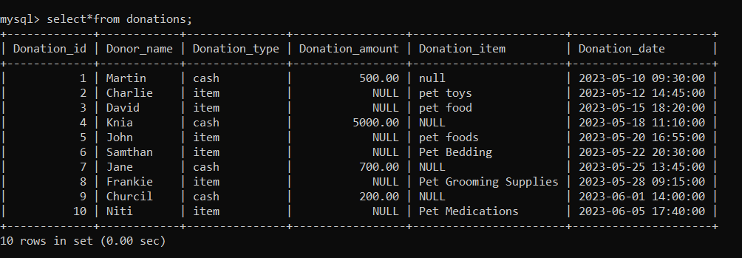

insert into adoption_events values

(1, 'Kolkata Canine Carnival', '2023-07-08 09:30:00', 'Eco Park'),

(2, 'Pune Paw Fest', '2023-08-12 13:15:00', 'Aga Khan Palace'),

(3, 'Jaipur Feline Fiesta', '2023-10-05 16:45:00', 'Jaipur Exhibition & Convention Center'),

(4, 'Goa Doggie Day Out', '2023-11-18 10:00:00', 'Miramar Beach Dog Park'),

(5, 'Pet Carnival Mumbai', '2023-06-15 10:00:00', 'Juhu Beach'),

(6, 'Bangalore Pet Expo', '2023-09-20 12:30:00', 'Bangalore International Exhibition Centre'),

(7, 'Delhi Adoption Drive', '2023-12-10 14:00:00', 'DLF Promenade Mall'),

(8, 'Hyderabad Pet Fair', '2024-03-25 11:45:00', 'Hitex Exhibition Center'),

(9, 'Chennai Mega Adoption Event', '2024-12-15 15:20:00', 'Express Avenue Mall'),

(10, 'Chennai Meow Mixer', '2024-04-02 16:10:00', 'Chennai Trade Centre');

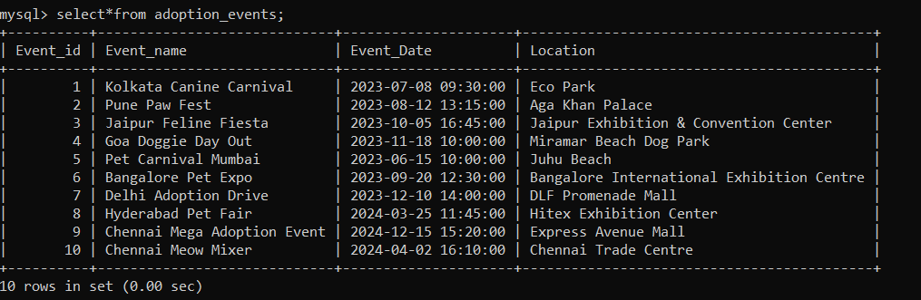

Participants

insert into participants value

(1, 'Pet Lovers Club', 'Adopter', 1),

(2, 'Happy Tails Foundation', 'Adopter', 2),

(3, 'Doggy Delight Rescue', 'Adopter', 3),

(4, 'Cat Haven', 'Shelter', 4),

(5, 'Pet Educators Network', 'Shelter', 1),

(6, 'Stray Angels', 'Shelter', 5),

(7, 'Rescue Rangers', 'Shelter',7),

(8,'Bark Buddies Team','Adopter',9),

(9, 'Caring Canines Club', 'Adopter',8),

(10, 'Meow Manor Volunteers', 'Shelter', 6);

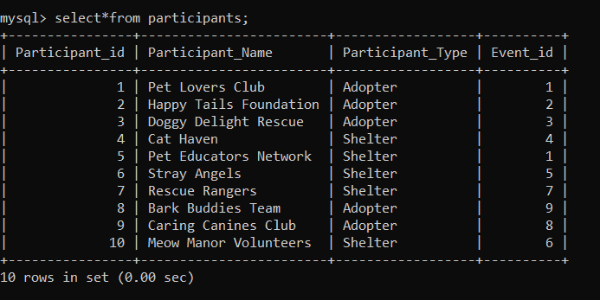

5. retrieves a list of available pets (those marked as available for adoption) from the "Pets" table.

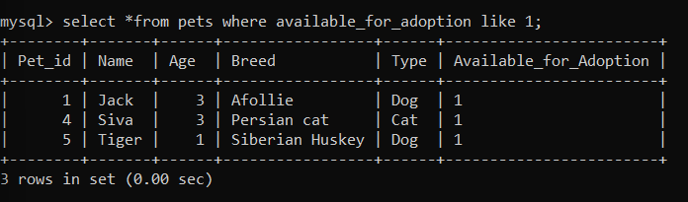

6. retrieves the names of participants (shelters and adopters) registered for a specific adoption event

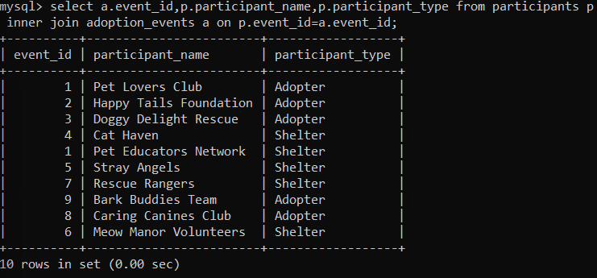

7. update its information (name and location) in the "Shelters" table. Use parameters to pass the shelter ID and the new information

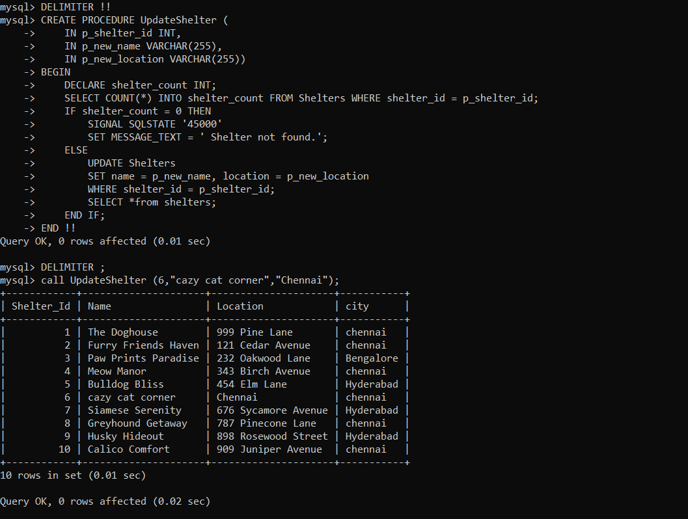

8. and retrieves the total donation amount

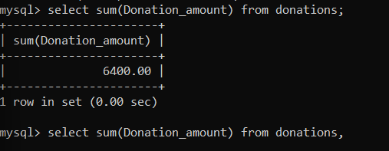

9. retrieves the names of pets from the "Pets" table that do not have an owner

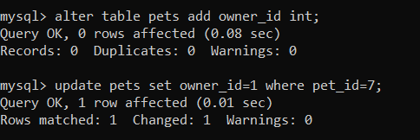

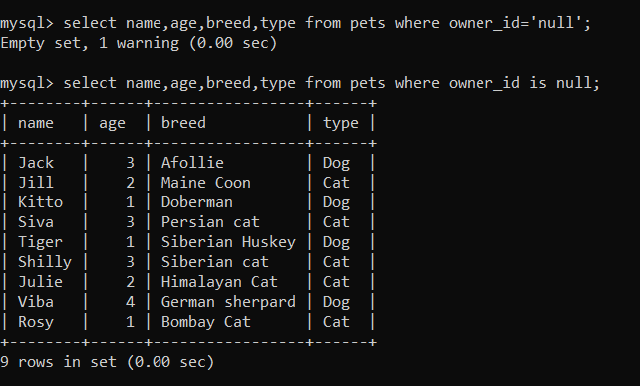

10. retrieves the total donation amount for each month and year

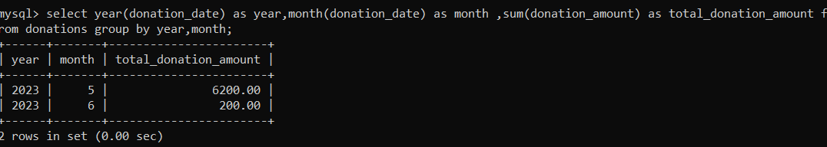

11. list of distinct breeds for all pets that are either aged between 1 and 3 years or older than 5 years

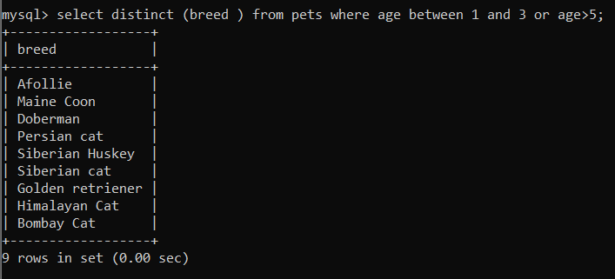

12. list of pets and their respective shelters where the pets are currently available for adoption.

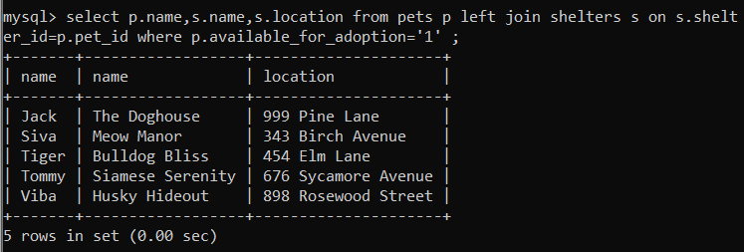

13. the total number of participants in events organized by shelters located in specific city- Chennai

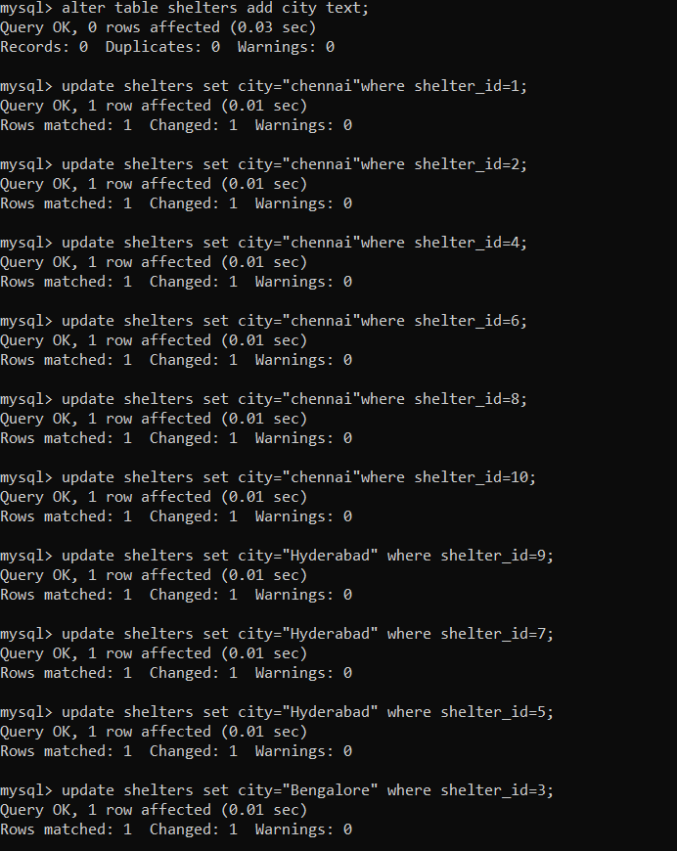

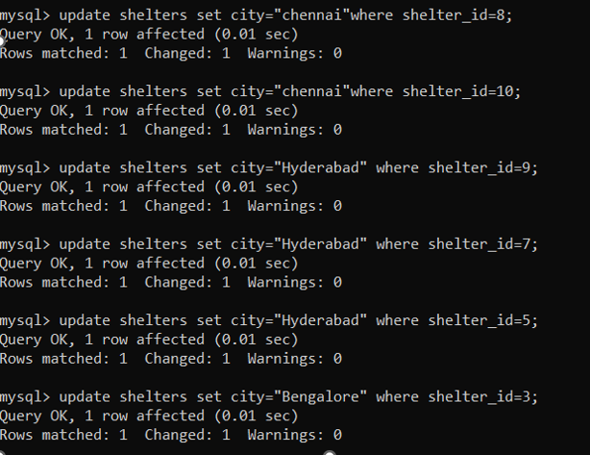

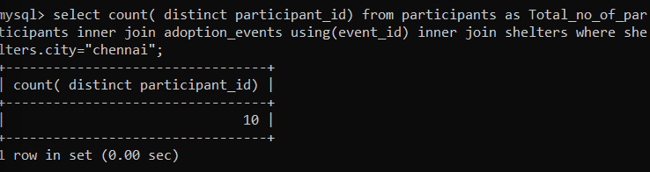

14. unique breeds for pets with ages between 1 and 5 years.

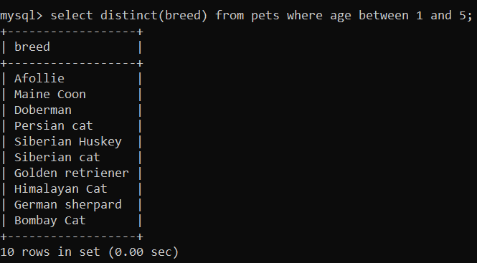

15. pets that have not been adopted by selecting their information from the 'Pet' table.

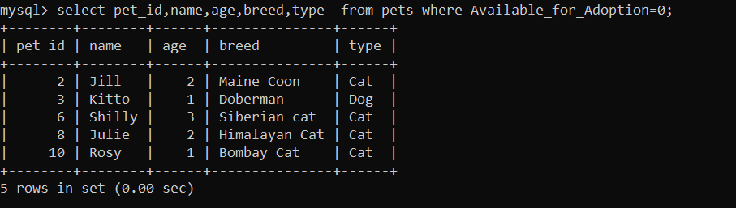

16. Retrieve the names of all adopted pets along with the adopter's name



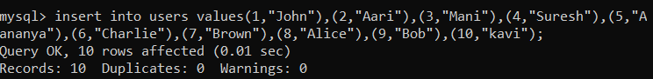

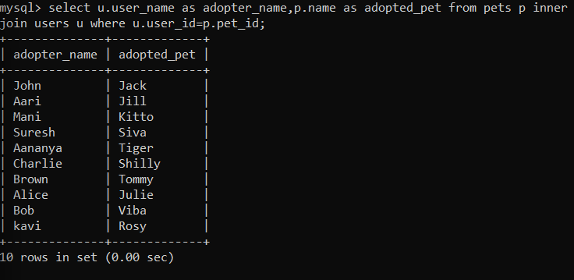

17. list of all shelters along with the count of pets currently available for adoption

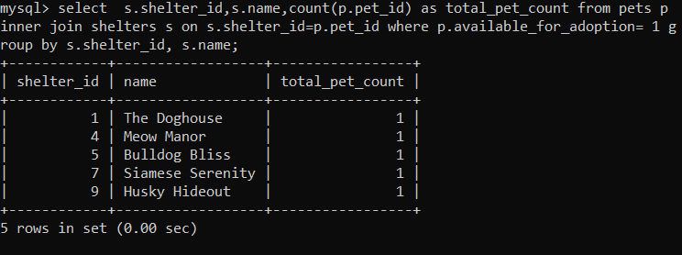

18. Find pairs of pets from the same shelter that have the same breed

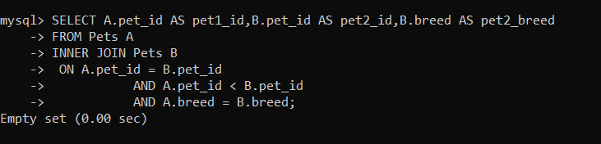

19. all possible combinations of shelters and adoption events.

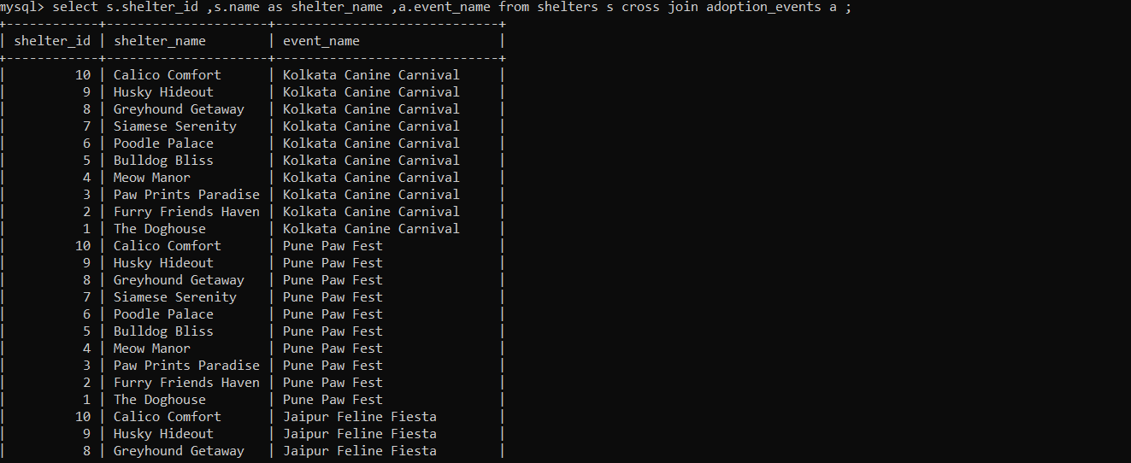

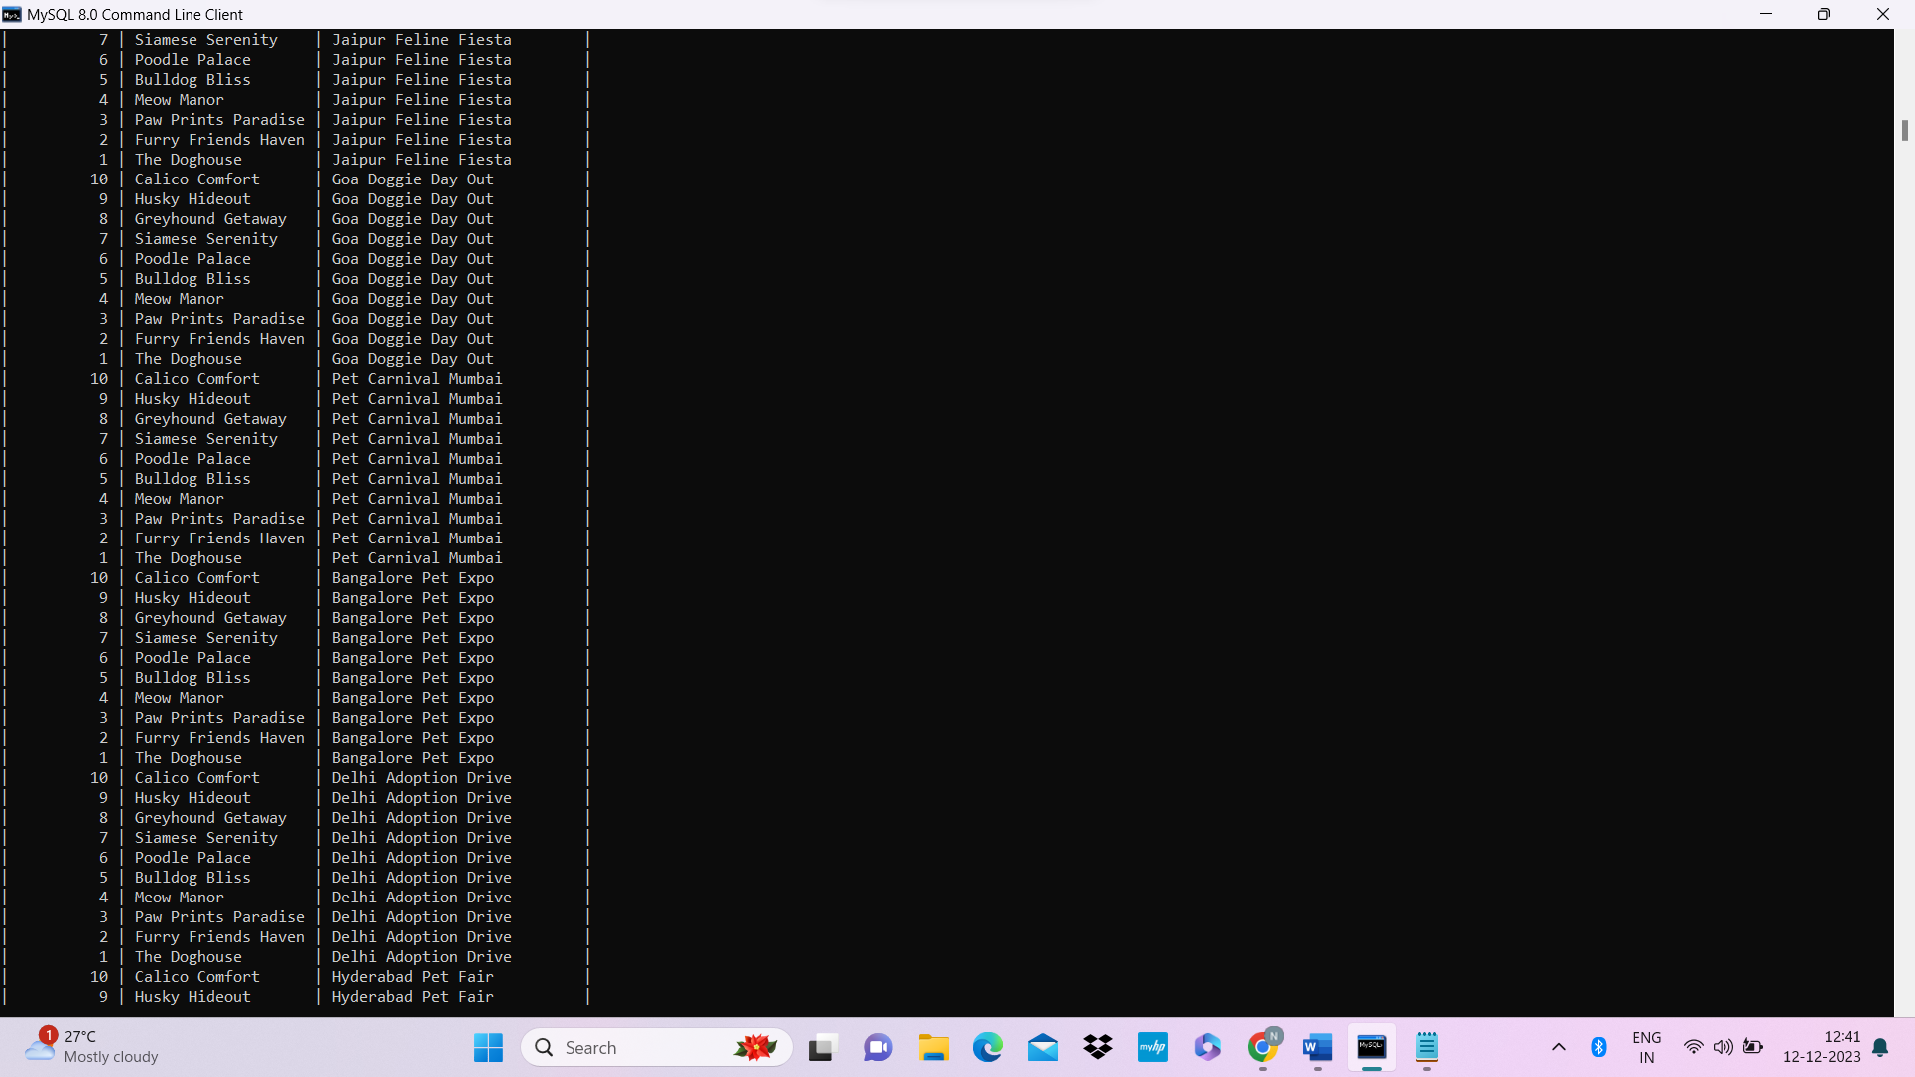

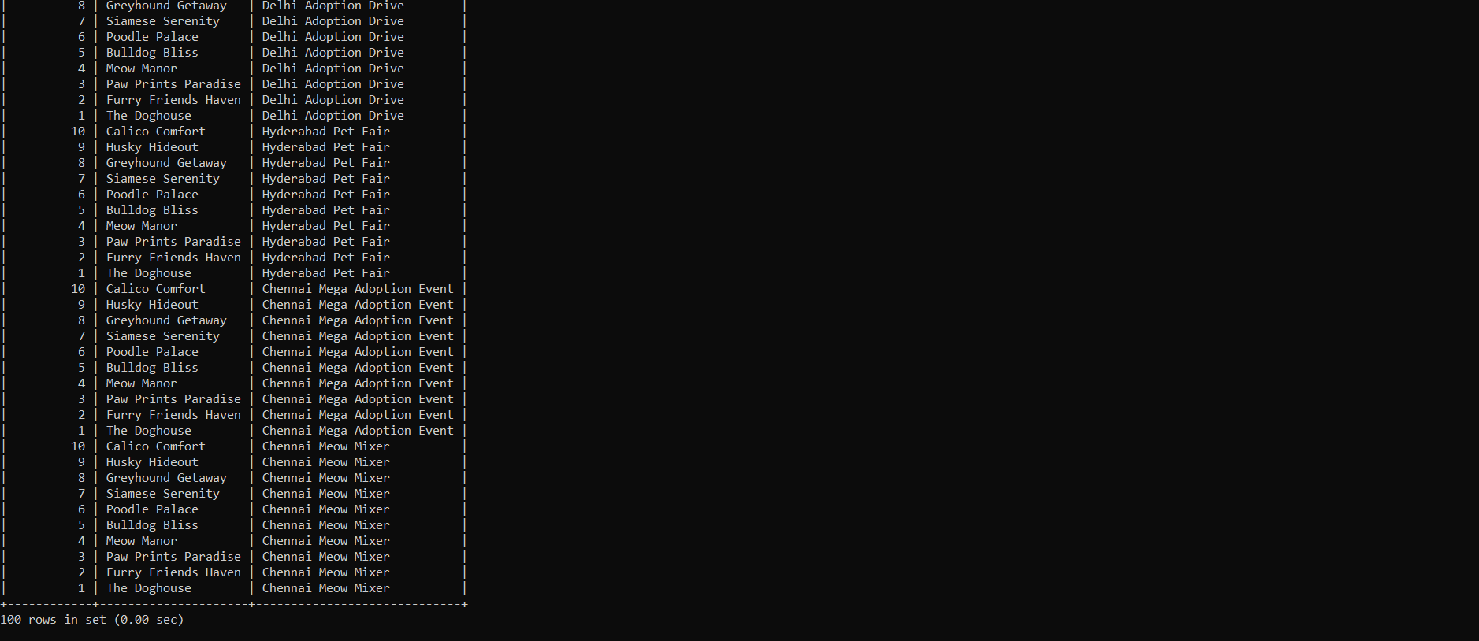

20. the shelter that has the highest number of adopted pets.

